This new book छकेसधातुवंसो (Chakesdhatuvaṃso) is to be placed under
Vaṃsa-Gantha-Saṅgaho, below the third book Sāsanavaṃsa.

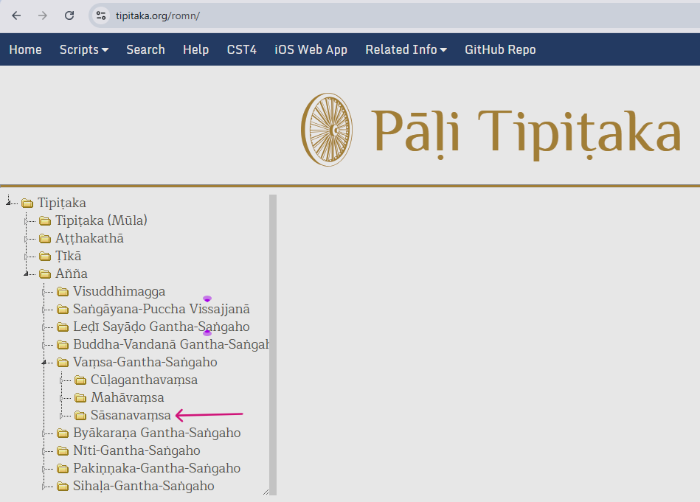

Below is given the naming system, and sequence corresponding to the 7 word files.

 छकेसधातुवंसो
 छकेसधातु
 सक्कथूपवंसो
 पज्जुन्नथूपवंसो
 मणिमेखलाथूपवंसो
 अद्धिकनाविकथूपवंसो
 वरुणनागराजथूपवंसो
 सत्तनाविकथूपवंसो

